Relationships & Health Education – Secondary
Name of school | Dene Academy
Staff member(s) responsible | Miss Lainé
Date of latest parental consultation | 09/09/2022 Parental Consultation  08/11/2022 Parental Newsletter  10/09/2023 Parental Consultation  10/01/23 Parental Newsletter  10/09/24 Parental Consultation  05/09/25 Parental Consultation
Date of latest Newsletters. | 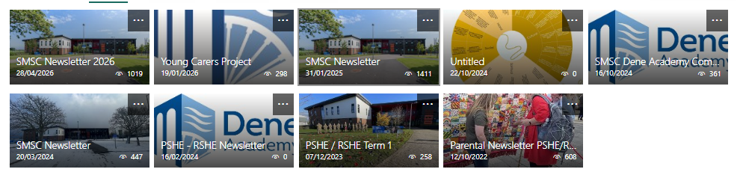

Our School Context, meeting the needs of the pupils, parents and the community
Dene Academy is a smaller than average, fully inclusive school of 655 pupils serving Peterlee, Horden, and surrounding villages. We work with former mining communities facing significant deprivation, with 63 percent of pupils eligible for free school meals and 64 percent classed as disadvantaged. The school sits in the highest quintile on the IDSR, with over 58 percent of pupils living in Bands A and B, the most deprived wards, and 27 percent in Band A alone. These factors highlight the need for accessible, supportive enrichment opportunities beyond the school day.
Top reported crimes
SOURCE Home | Police.uk
Most commonly reported crimes during Apr 2026

Violence and sexual offences 94

Shoplifting 38

Anti-social behaviour 32

Criminal damage and arson 31

Drivers of differences in health outcomes
SOURCE InstantAtlas Durham – Health & Wellbeing – JSNAA
Our health and the health of our population is dependent on a complex relationship between our genes, the broader factors of health care, our behaviours and the wider determinants of health. In the image below, we show an estimate of the contribution that these wider factors have on health and wellbeing and ultimately lives being cut short.
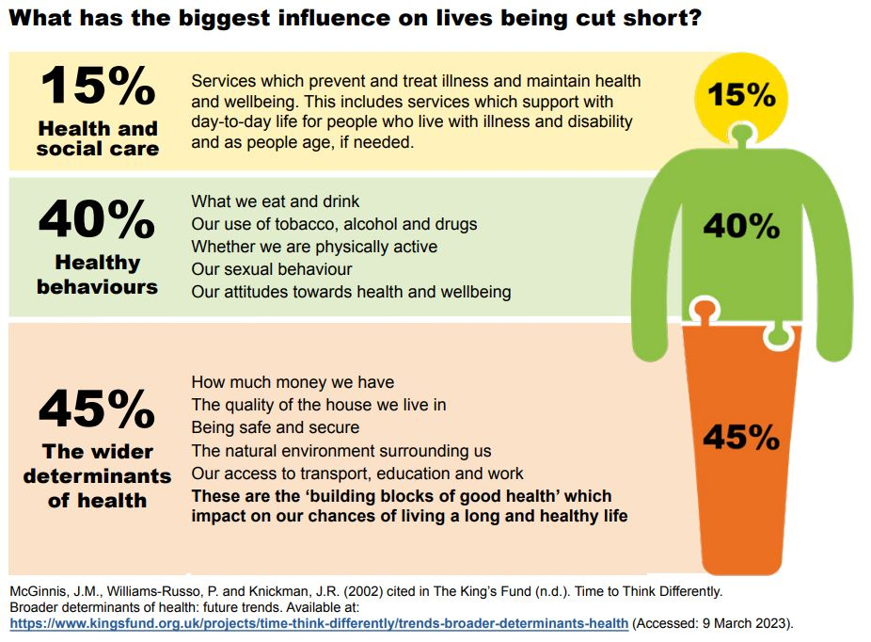

School intent
At Dene Academy, we are dedicated to delivering a supportive, exciting and engaging education experience that provides opportunities for challenge, creativity and independent learning. We aim for our students to feel a sense of community; to grow in confidence and to feel empowered.

Vision
As a school, we want our students to be resilient, confident and to secure the best academic outcomes possible. We believe that all students can be successful irrespective of their background or starting points in life. We are committed to being a centre of excellence for all students.
As a school we are committed to:
- Delivering an innovative & engaging education experience that ensures all students have the opportunity to be successful;
- Exceptional teaching & learning;
- Equipping students & the personal and social skills required in order for them to be confident and well-rounded citizens who positively contribute to society;
- Cultivating a school culture of resilience, high aspirations, integrity, respect & happiness that is rooted in support, ambition and achievement.
- outstanding pastoral care to meet the needs of every student.

Define your RSHE Programme
You need to state here what your programme will cover and how you choose to define it. Relationships, Sex Education and Health Education and how these fit within your school core values and vision.
Organisation, content and delivery of RSHE
Explain how, where and when RSHE is taught. You may want to briefly bullet point what is broadly being delivered in different year groups e.g. This section also needs to include how RSHE teaching, and learning will be assessed.

Teachers who will be delivering relationships, sex and health education are outlined below:

Relationship education content per year group:
KS3 | KS4
The Personal, Social, Health and Economic (PSHE) education and Relationships, Sex and Health Education (RSHE) is a sequenced, spiral programme that builds on prior learning as pupils progress through school. Each child receives age-appropriate learning. The aim of RSE is to provide children with age-appropriate information, explore attitudes and values and develop skills in order to empower them to make positive decisions about their health-related behaviour. This should take place with consideration of the qualities of relationships within families. PSHE, aims to give children the knowledge, skills and understanding to lead confident, healthy and independent lives. RSHE aims to support the social and emotional development of children and young people regarding sex, health and relationships.

There are three categories of learning rotate throughout the year. These are: Relationships, Living in the wider world and Health & Wellbeing.

Year 7 | Year 10
Building Relationships  Self-worth, romance and friendships (including online) and relationship boundaries.  Programme of Study references: H1, R2, R9, R11, R13, R14, R16, R24  Diversity and Growing Up  Diversity, Prejudice, and Bullying.  Programme of Study references R3, R38, R39, R40, R41 | Addressing extremism and radicalisation  Community cohesion and challenging Extremism.  Programme of Study references: R5, R6, R9, R10, R14, R28, R29, R30, R31, R34, L24, L26, L27, L28, L29  Healthy relationships  Relationships and sex expectations,  myths, pleasure and challenges, including  the impact of the media and pornography  PoS refs: R1, R2, R3, R6, R7, R8, R14, R15, R18, R19, R22, R28, R29, R30, R31
Year 8 | Year 11
Identity and relationships  Gender identity, sexual orientation, consent, ‘sexting’, and an introduction to contraception.  Programme of Study references: H35, H36, R4, R5, R10, R16, R18, R24, R25, R26, R27, R29, R30, R32  Discrimination  Discrimination in all its forms, including: racism, religious discrimination, disability,  discrimination, sexism, homophobia, biphobia and transphobia.  PoS refs: R39, R40, R41, R3, R4, R42, R43 | Intimate relationships  Relationships and sex education  including consent, contraception,  the risks of STIs, and attitudes to  pornography  PoS refs: R7, R8, R11, R12, R18, R24,  R26, R27, R28, R29, R30, R31, R32, R33, R34, L21  Identity and relationships  Gender identity, sexual orientation,  consent, ‘sexting’ and honour based violence.  Programme of Study references H35, H36, R4, R5, R10, R16,  R18, R24, R25, R26, R27, R29, R30, R32  Families  Different families and parental responsibilities, pregnancy, marriage and forced marriage and changing relationships.  Pos refs: H30, H31, H32, H33, R4, R11, R12, R13, R24, R25, R26, R27, R33
Year 9
Intimate Relationships

RSHE
Including consent, contraception,
The risks of STI’s, and attitudes to
Pornography.

Programme of Study references: R7, R8, R11, R12, R18, R24, R26, R27, R28, R29, R30, R31, R32, R33,
R34, L21

Respectful relationships

Families and parenting, healthy Relationships, conflict resolution, and Relationship changes

Pos refs: H2, R1, R6, R19, R21, R22, R23,
R35, R36

If N/A please leave blank.

Health education content per year group:
KS3 | KS4
The Personal, Social, Health and Economic (PSHE) education and Relationships, Sex and Health Education (RSHE) is a sequenced, spiral programme that builds on prior learning as pupils progress through school. Each child receives age-appropriate learning. The aim of RSE is to provide children with age-appropriate information, explore attitudes and values and develop skills in order to empower them to make positive decisions about their health-related behaviour. This should take place with consideration of the qualities of relationships within families. PSHE, aims to give children the knowledge, skills and understanding to lead confident, healthy and independent lives. RSHE aims to support the social and emotional development of children and young people regarding sex, health and relationships.

There are three categories of learning rotate throughout the year. These are: Relationships, Living in the wider world and Health & Wellbeing.

Year 7 | Year 10
Transition and safety  Transition to secondary school and  personal safety in and outside school,  including First Aid.  PoS refs: H1, H2, H30, H33, R13, L1, L2  Mental Health & Choices  Healthy routines, influences on health, and LQBTQ+.  PoS refs: H5, H13, H14, H15, H16, H17, H18, H20, H22, H34 | Mental health  Mental health and ill health, stigma, safeguarding health, including during periods of transition or change.  PoS refs: H2, H5, H6, H7, H8, H9, H10  Exploring influence  The influence and impact of drugs, gangs, role models and the media.  PoS refs: H19, H20, H21, R20, R35, R36, R37
Year 8 | Year 11
Drugs and Alcohol  Alcohol and drug misuse and pressures relating to drug use.  PoS refs: H23, H24, H25, H26, H27, H29, H31, H5, R42, R44  Emotional wellbeing  Mental health and emotional wellbeing, including body image and coping strategies.  PoS refs: H3, H4, H6, H7, H8, H9, H10,  H11, H12, L24 | Building For The Future  Self-efficacy, stress management, and future opportunities  PoS refs: H2, H3, H4, H8, H12, H22, H23, H26, R14, R15, R16, R19, R35, L11, L12, L22, L23, L26
Year 9
Peer influence, substance use and gangs

Healthy and unhealthy friendships,
Assertiveness, substance misuse, and
Gang exploitation.

Pos refs: H24, H25, H27, H28, H29, R1,
R20, R37, R42, R44, R45, R46, R47

Healthy lifestyle

Diet, exercise, lifestyle balance and Healthy choices, and first aid.

Pos refs: H3, H14, H15, H16, H17, H18, H19, H21

If N/A please leave blank.
Living in the Wider World - Citizenship
KS3 | KS4
The Personal, Social, Health and Economic (PSHE) education and Relationships, Sex and Health Education (RSHE) is a sequenced, spiral programme that builds on prior learning as pupils progress through school. Each child receives age-appropriate learning. The aim of RSE is to provide children with age-appropriate information, explore attitudes and values and develop skills in order to empower them to make positive decisions about their health-related behaviour. This should take place with consideration of the qualities of relationships within families. PSHE, aims to give children the knowledge, skills and understanding to lead confident, healthy and independent lives. RSHE aims to support the social and emotional development of children and young people regarding sex, health and relationships.

There are three categories of learning rotate throughout the year. These are: Relationships, Living in the wider world and Health & Wellbeing.

Year 7 | Year 10
Developing skills and aspirations  Careers, Money Skills  and raising aspirations  PoS refs: R15, R39, L1, L4, L5, L9, L10, L12, H32, L15, L16, L17, L18  financial decision making  Digital Safety  PoS refs: H32, L15, L16, L17, L18 | Financial decision making  The impact of financial decisions, debt, gambling and the impact of advertising on financial choices.  Diversity  Diversity, prejudice, and bullying  PoS refs: R3, R38, R33, R39, R40, R41  PoS refs: H25, R38, L16, L17, L18, L19,  L20, L25  Understanding influence and you  Students will recognise their rights within the workplace and within relationships. They will recognise triggers and where to seek help for suicide prevention. They will recognise unhealthy relationship values and where to get help.  H9, H8, H6, H22, H23, R3, R4, R6, R7, R8, R11, R12, R21, R29, R30, R31, R32, R35, R36, R37, R38
Year 8 | Year 11
Community and Careers  Equality of opportunity in careers and life choices, and different types and patterns  of work.  PoS refs: R39, R41, L3, L8, L9, L10, L11, L12  Digital literacy  Online safety, digital literacy, media reliability, and gambling hooks.  PoS refs: H3, H30, H32, R17, R35, R36, L17, L19, L20, L21, L22, L23, L24, L25, L26, L27 | Next steps  Application processes, and skills for further education, employment and career progression.  PoS refs: L1, L2, L3, L4, L6, L7, L8, L11, L12, L21  Independence  Responsible health choices, and safety in independent contexts  PoS refs: H3, H4, H11, H13, H14, H15, H18, H22, H23,
Year 9 | Y11 Careers
Setting goals  Learning strengths, career options and  Goal setting as part of the GCSE options  Process.  Pos refs: L2, L3, L6, L7, L8, L9, L11, L12,  L13, L14  Employability skills  Employability and online presence  Pos refs: R13, R14, L2, L4, L5, L8, L9, L14, L21, L24, L27 | Students will learn about the next steps and how to apply for colleges and higher education.  Students will learn:  - How to apply for college.  - How to apply for an apprenticeship.  - What the difference is between higher education qualifications.  - How to choose a career path that’s right for them.

Right to withdraw:
Parents are informed of the Bigger Picture showing each lesson title and the Learning Journeys at the start of the Academic year. Parents are also given a letter that explains the right to withdraw. If a parent wishes to withdraw, a meeting is arranged with the subject lead and further discussions are facilitated. The policy is followed.

Please see below a useful document produced by the government, which provides answers to frequently asked questions:
https://www.gov.uk/government/news/relationships-education-relationships-and-sex-education-rse-and-health-education-faqs
Relationships and sex education (RSE) and health education - GOV.UK (www.gov.uk)

